**Question 1:** A triangular prism with a base side of 30 mm and height of 60 mm rest on its base on HP with a rectangular face perpendicular to VP. It is cut by an auxiliary inclined plane such that true shape of the section is an isosceles triangle of maximum size. Draw the top view, front view and true shape of the section.

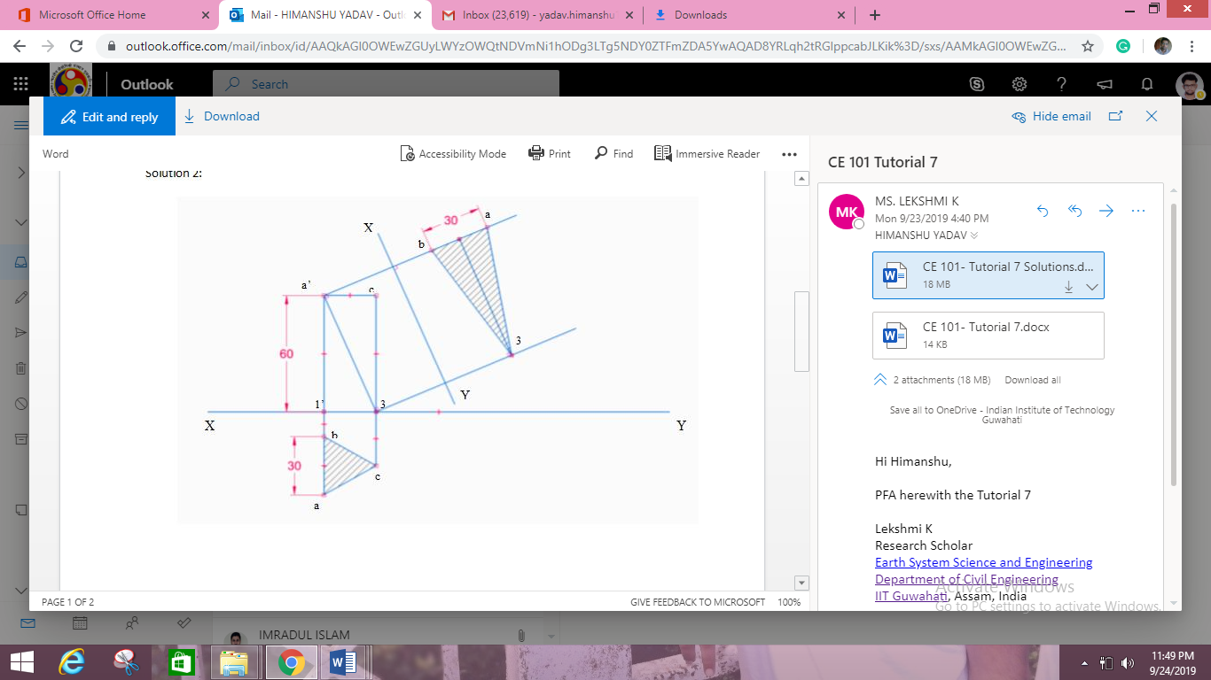

**Question 2:** A hexagonal pyramid, base 30 mm side and axis 65 mm long is resting on its base on the HP, with two edges of the base parallel to the VP. It is cut by a section plane perpendicular to VP and inclined at 45º to the HP, intersecting the axis at a point 25 mm above the base. Draw the front view, sectional top view, sectional side view and true shape of the section.

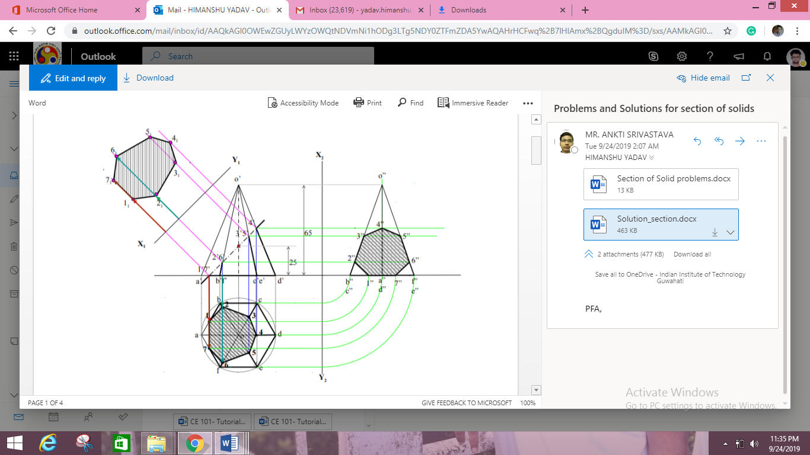

**Question 3:** A cone, base 45 mm diameter and axis 55 mm long is resting on the H.P. on its base. It is cut by a section plane, perpendicular to both the H.P. and the V.P. and 6 mm away from the axis. Draw its front view, top view and sectional side view.

